AMENITIES MAGNET
Identifying Key Drivers of Residential Rental Prices in Germany

Machine Learning Modelling
CSE 6242 — Team #146 | Data & Visual Analytics
Terence B Buttrick · Ahmadou Diallo · Dionysios Siachras · Neerav Gala · Supraja Venkatesh
Summary of Overall modelling approaches ( Best performing )

Dataset  268,526 listings | Best Model  XGBoost |  | Best R²  0.8388

1. Summary
This report presents the complete analytical pipeline for the Amenities Magnet project — a data-driven tool to identify and visualise the key drivers of residential rental prices across German cities. Using 268,526 ImmoScout24 listings (2018–2020), we trained and evaluated eleven regression models and one classification model, with XGBoost emerging as the best performer.

Key Results

- XGBoost achieved RMSE = €197/month and R² = 0.8388 on the held-out test set — a 60% reduction in error vs the null model (€491 RMSE).
- Tree-based models (XGBoost, GBM, Random Forest) outperform all linear models by a margin of ~€60/month RMSE, confirming strong non-linear interactions in the data.
- livingSpace is the single most powerful predictor (mean |SHAP| = €156), followed by serviceCharge (€54), building_age (€37), hasKitchen (€32), and state_Bayern (€31).
- Ridge ≈ OLS confirms the absence of multicollinearity (all VIF < 3.5) — penalised linear regression adds no benefit here.
- The optional price-tier classifier achieves 79% overall accuracy, with High (87%) and Low (81%) tiers performing best.
- log_price_per_sqm (skew = 0.98) is the recommended target for city-level dashboard comparisons.

2. Data & Preprocessing Pipeline

2.1 Dataset Overview
The raw dataset was sourced from Kaggle (ImmoScout24 / corrieaar, 2020) containing apartment rental listings scraped from Germany's largest property platform between 2018 and 2020. After the data engineering pipeline, the modelling-ready dataset contains the following characteristics:

Attribute | Value
Raw records | 268,850 rows
After data cleaning | 268,632 rows (218 removed, 0.08%)
After modelling filters | 268,526 rows (living space ≥10 sqm; price/sqm 1–100 €)
Train set (80%) | 214,820 rows
Test set (20%) | 53,706 rows
Total features (raw) | 49 columns
Features after pipeline | 23 features → 75 encoded dimensions (after OHE)
Geographic coverage | All 16 German federal states
Time period | Approximately 2018–2020
Primary target | baseRent (EUR/month)
Secondary target | log_price_per_sqm — ln(1 + price_per_sqm)
Missing values (post-pipeline) | 0 — fully imputed by data engineering team

2.2 Feature Engineering
Ten features were engineered from raw columns to improve model performance and directly support the Amenities Magnet concept:

Feature | Purpose & Construction
price_per_sqm | baseRent ÷ livingSpace. Primary normalised price metric for city comparisons.
log_price_per_sqm | ln(1 + price_per_sqm). Near-normal (skew=0.98 vs 49.6 raw). Secondary regression target and dashboard metric.
building_age | 2019 − yearConstructed. Older buildings generally command lower rents unless renovated.
amenity_score | Sum of 6 boolean amenity flags (0–6). Core Amenities Magnet feature — directly measures amenity density.
is_ground_floor | Binary: floor == 0. Ground floor units differ systematically in price and desirability.
floor_ratio | floor ÷ numberOfFloors. Normalised vertical position (0=ground, 1=top).
condition_score | 10 condition categories mapped to ordinal scale 0–9. Preserves ordering information.
interior_score | Interior quality encoded 1–4 (simple → luxury). Ordinal — not one-hot encoded.
central_heating | Binary: 1 = modern central/district/heat-pump heating; 0 = older gas/electric systems.
state / city | Cleaned versions of regio1/regio2. State used in modelling (OHE); city for SHAP dashboard analysis.

2.3 Preprocessing Decisions
The following preprocessing steps were applied, all fit on the training set only to prevent data leakage:
- StandardScaler applied to all 18 numeric and binary features (mean=0, std=1).
- OneHotEncoder applied to 5 categorical features (heatingType, condition, interiorQual, typeOfFlat, state), expanding from 23 to 75 encoded dimensions. handle_unknown='ignore' used to handle unseen categories at test time.
- floor and numberOfFloors clipped at the 99th percentile — raw data contained values of 999 (clear data entry errors identified in EDA).
- totalRent and price_per_sqm excluded from model features to prevent target leakage (they are derived from or highly collinear with baseRent).
- city excluded from global model features due to extreme cardinality (hundreds of values), but retained for city-level SHAP analysis.

3. Exploratory Data Analysis

3.1 Target Variable Analysis
Understanding the distribution of the target variable is critical before modelling. The plots below show the raw baseRent alongside the log-transformed log_price_per_sqm.

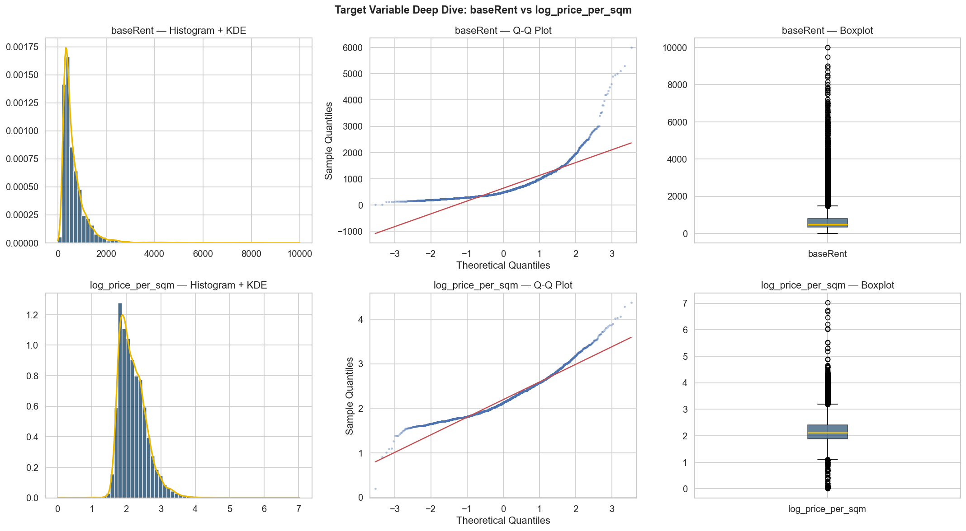
Figure: Target variable distributions: baseRent (top) vs log_price_per_sqm (bottom). Histogram+KDE, Q-Q plot, and boxplot.

Variable | Mean | Median | Skewness | Kurtosis | Min | Max
baseRent | €646 | €490 | 3.36 | 22.4 | €1 | €10,000
livingSpace | 73 sqm | 67 sqm | 1.92 | 11.1 | 1 sqm | 1,000 sqm
price_per_sqm | €8.77 | €7.37 | 49.6 | 6,982 | €0.01 | €1,130
log_price_per_sqm | 2.19 | 2.12 | 0.98 | 1.82 | 0.01 | 7.03
building_age | 50 yrs | 46 yrs | 0.80 | 0.53 | 0 yrs | 219 yrs
amenity_score | 2.11 | 2 | 0.29 | -0.30 | 0 | 6

Key finding: baseRent has extreme right skew (3.36) and kurtosis (22.4), driven by high-value outliers. Normality tests (Shapiro-Wilk, KS, D'Agostino-K²) all reject normality at p < 0.0001. The log-transformed log_price_per_sqm (skew=0.98, kurtosis=1.82) is substantially closer to normal — this is the recommended target for linear model families and city-level dashboard comparisons.

3.2 Univariate Distributions
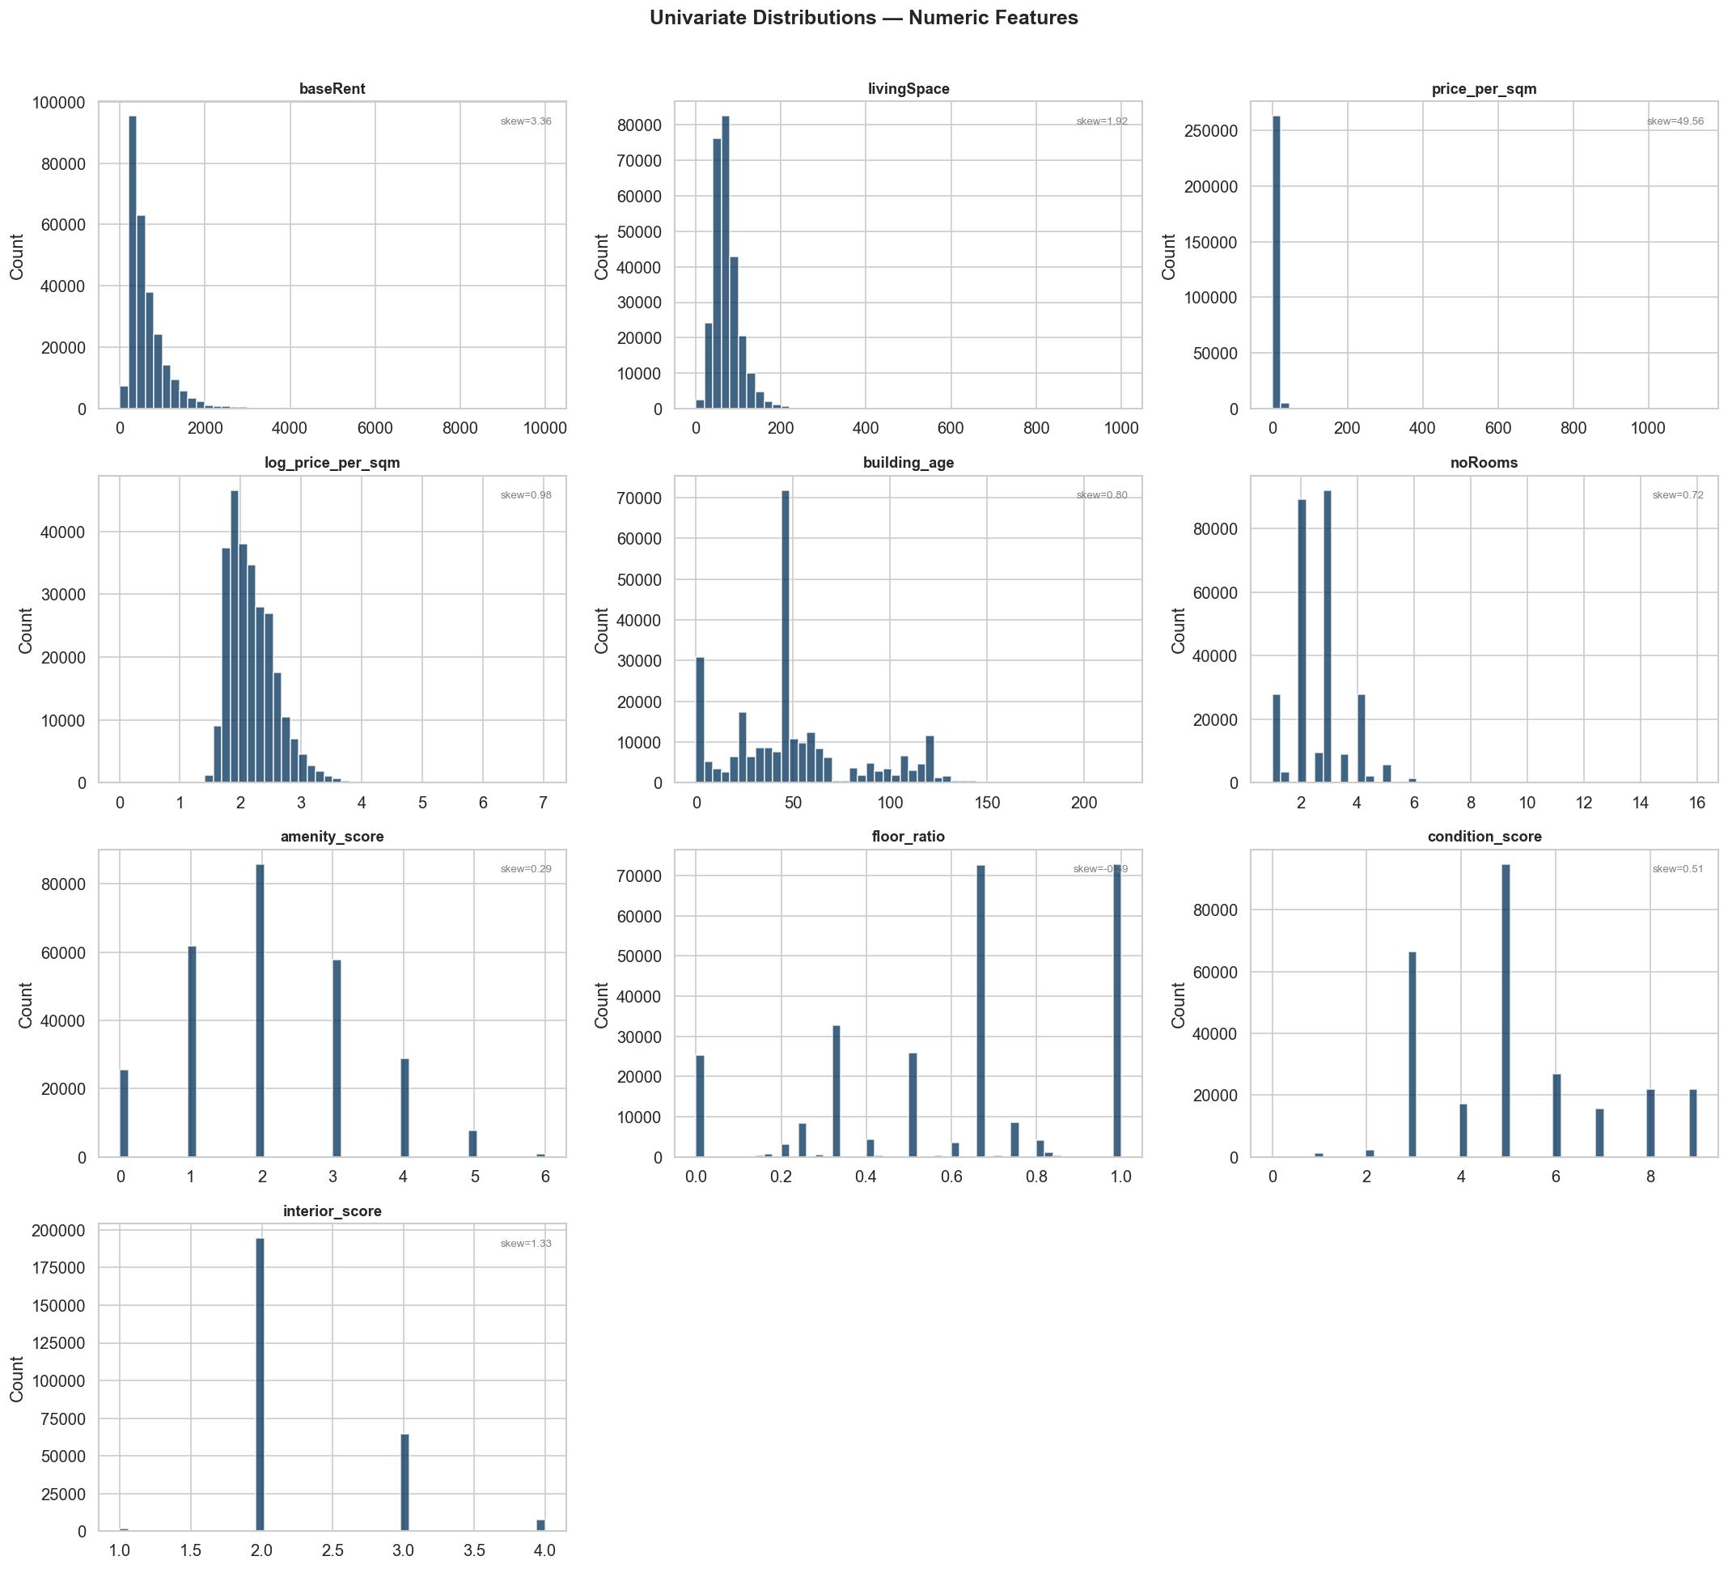
Figure: Histograms of all numeric features. Note the right-skewed distributions of baseRent, serviceCharge, and totalRent.

Notable observations from univariate analysis:
- condition_score and interior_score are heavily left-skewed — most listings cluster at 'well-kept'/'normal' quality (scores 4–6), with few at the extremes.
- amenity_score peaks at 2 (approximately normally distributed, range 0–6) — listings typically have balcony + kitchen as the baseline amenity combination.
- building_age is right-skewed (mean=50, max=219) — dominated by post-war construction stock (1950s–1970s).
- floor and numberOfFloors showed extreme values (max=999) — clipped at the 99th percentile before modelling.

3.3 Correlation Analysis
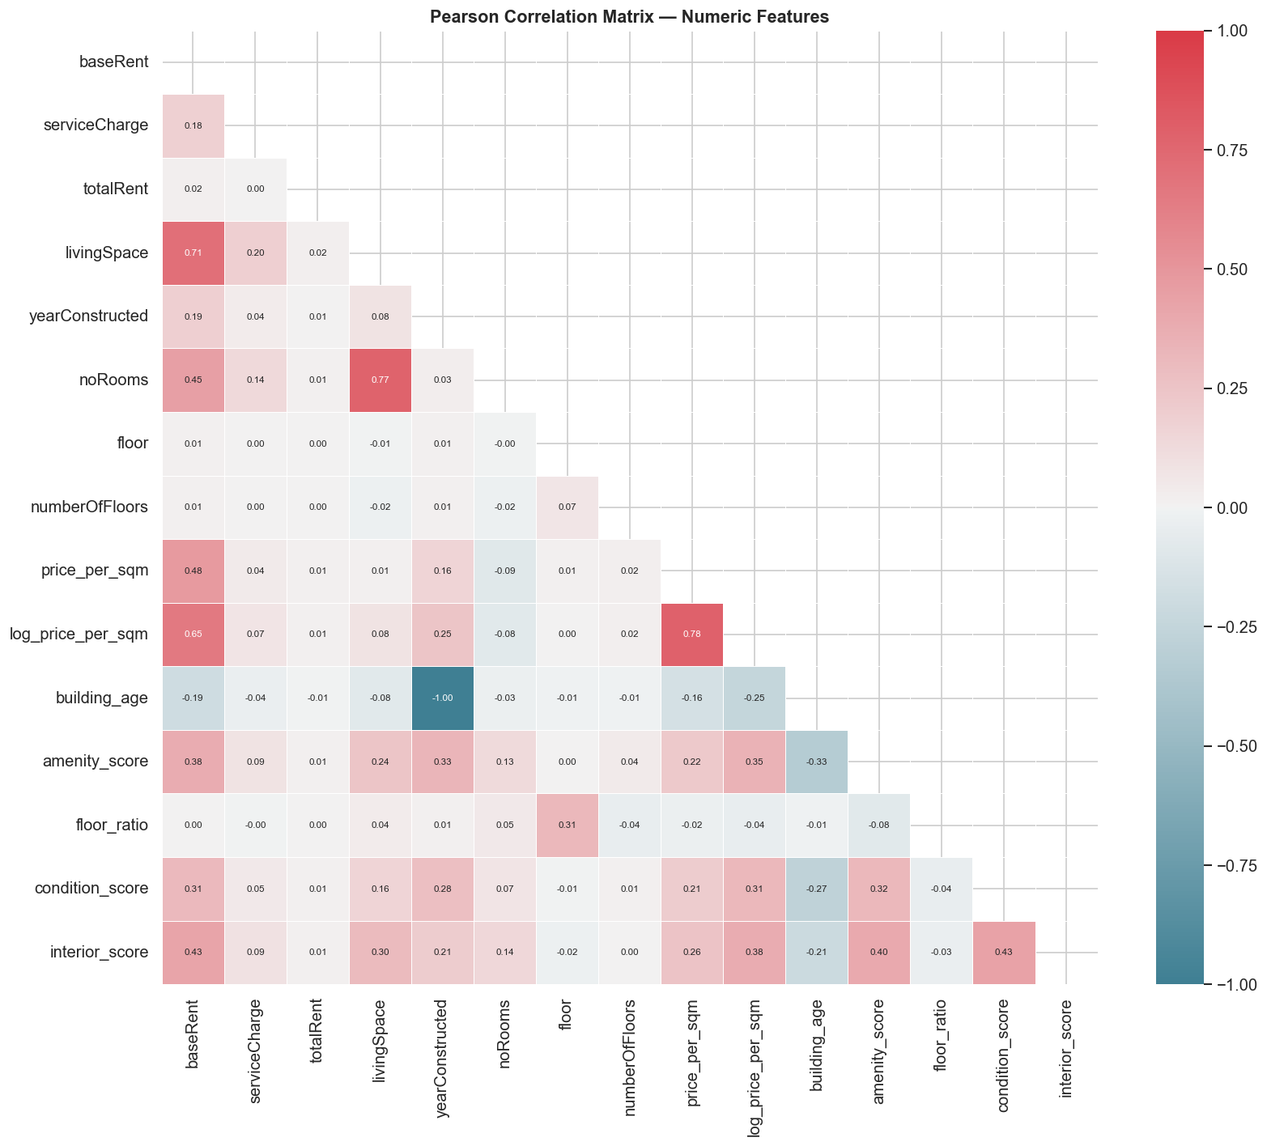
Figure: Pearson correlation matrix (lower triangle). Strongest correlates of baseRent: livingSpace (0.71), noRooms (0.45), interior_score (0.43).

The correlation matrix reveals several important patterns for model selection and interpretation:

Feature | r with baseRent | Implication
livingSpace | 0.71 | Dominant linear predictor. Non-linear effects also expected (diminishing returns at large sizes).
noRooms | 0.45 | Correlated with livingSpace (r≈0.60) but provides independent information about apartment layout.
interior_score | 0.43 | Ordinal encoding works well here — the quality premium is approximately monotone.
log_price_per_sqm | 0.65 | Strong correlation with baseRent confirms it as a meaningful secondary target.
amenity_score | 0.38 | Core project feature — each additional amenity associated with higher rent.
condition_score | 0.31 | Positive but weaker than interior quality — condition has a floor effect for 'habitable' apartments.
building_age | -0.19 | Negative: older buildings command lower rents on average, though renovated older stock breaks this pattern.
serviceCharge | 0.18 | Moderate correlation — reflects building size/quality but is partially administrative.

3.4 Multicollinearity Check — Variance Inflation Factors
VIF was computed for all 10 numeric model features. All values were below 3.5, indicating no multicollinearity concern:

Feature | VIF | Interpretation
livingSpace | 3.23 | Highest VIF — correlated with noRooms (expected). Below threshold of concern (5.0).
noRooms | 2.62 | Correlated with livingSpace. Both retained as they capture different aspects.
floor_ratio | 1.64 | Safe. Derived from floor/numberOfFloors.
is_ground_floor | 1.63 | Safe. Overlaps with floor_ratio but captures a distinct category effect.
interior_score | 1.44 | Safe. Ordinal encoding reduces collinearity vs one-hot.
serviceCharge | 1.40 | Safe. Independent of baseRent despite moderate correlation.
amenity_score | 1.36 | Safe. Additive score design minimises collinearity.
condition_score | 1.31 | Safe.
building_age | 1.17 | Safe. Near-independent of other features.
central_heating | 1.02 | Safe. Nearly orthogonal.

Why this matters for modelling: All VIF < 3.5 means Ridge regression provides no advantage over OLS in handling collinearity — exactly what the modelling results confirmed (Ridge RMSE = OLS RMSE = 261.42). The data is well-conditioned for all model families.

3.5 Geographic Analysis
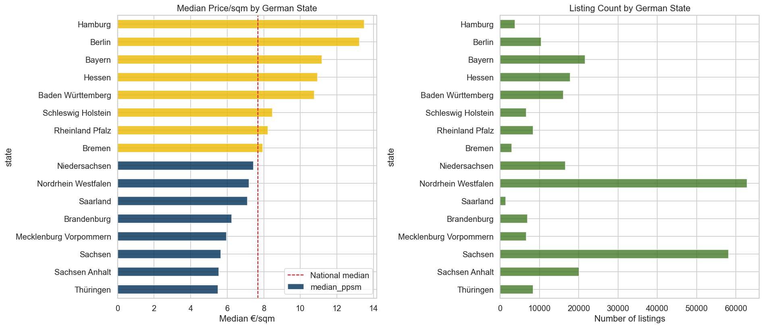
Figure: Median price/sqm (left) and listing count (right) by German federal state.

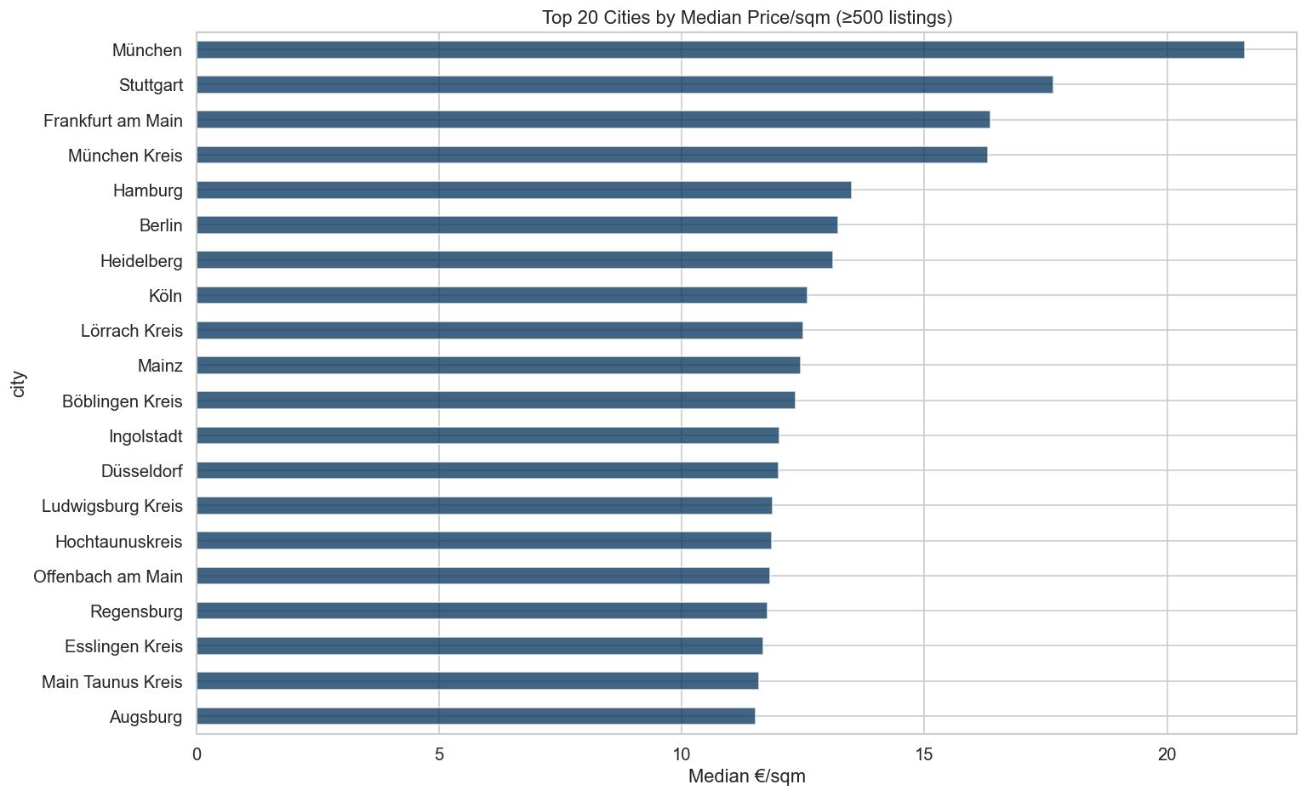
Figure: Top 20 cities by median price/sqm (minimum 500 listings).

Geographic variation is one of the most significant drivers of rental prices. Key findings:
- Bayern (Bavaria) and Hamburg command the highest median prices per sqm nationally, confirmed by OLS state coefficients of +€225 and +€323 respectively.
- Eastern German states (Sachsen, Thüringen, Sachsen-Anhalt, Brandenburg, Mecklenburg-Vorpommern) consistently show negative OLS coefficients (−€100 to −€156), reflecting structural economic differences.
- The gap between the highest-priced state (Bayern) and lowest (Thüringen) represents approximately €380/month in rent for an otherwise identical apartment.
- This confirms the need for city-level modelling in the dashboard — a single national model cannot capture local market conditions.

3.6 Amenity Analysis
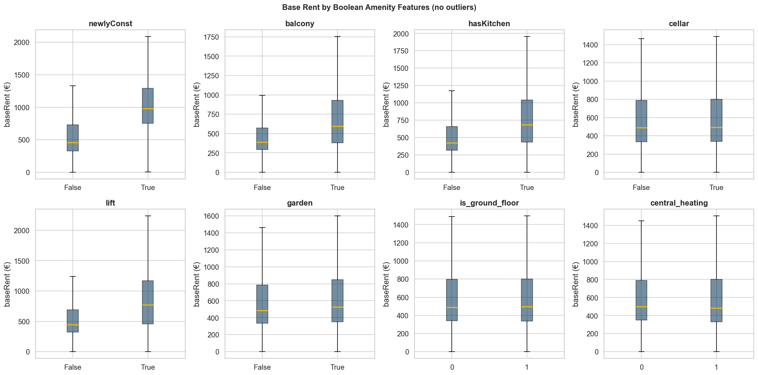
Figure: Median baseRent by binary amenity feature (Yes vs No). Lift shows the largest premium (~€120/month).

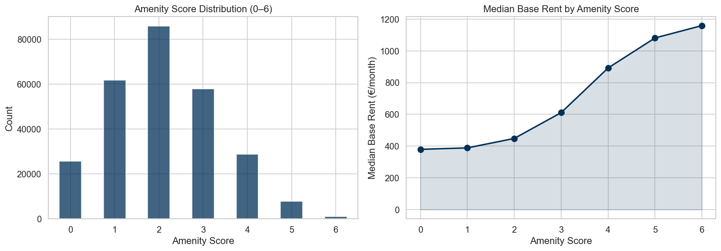
Figure: Amenity score distribution (left) and median rent by score (right). Clear monotone increase from score 0 to 6.

Amenity features directly support the core project concept:
- lift shows the largest individual premium (~€120/month median difference), reflecting its association with larger/higher-quality buildings.
- hasKitchen is the most impactful per SHAP analysis (mean |SHAP| = €31.65), partly because its absence is a strong signal of budget or student housing.
- amenity_score shows a clear monotone relationship with rent — each additional amenity is associated with approximately €40–60/month in additional rent at the median.
- newlyConst, balcony, garden, and cellar all show meaningful premiums, consistent with the SHAP rankings.

3.7 Regression Assumptions — OLS Diagnostics
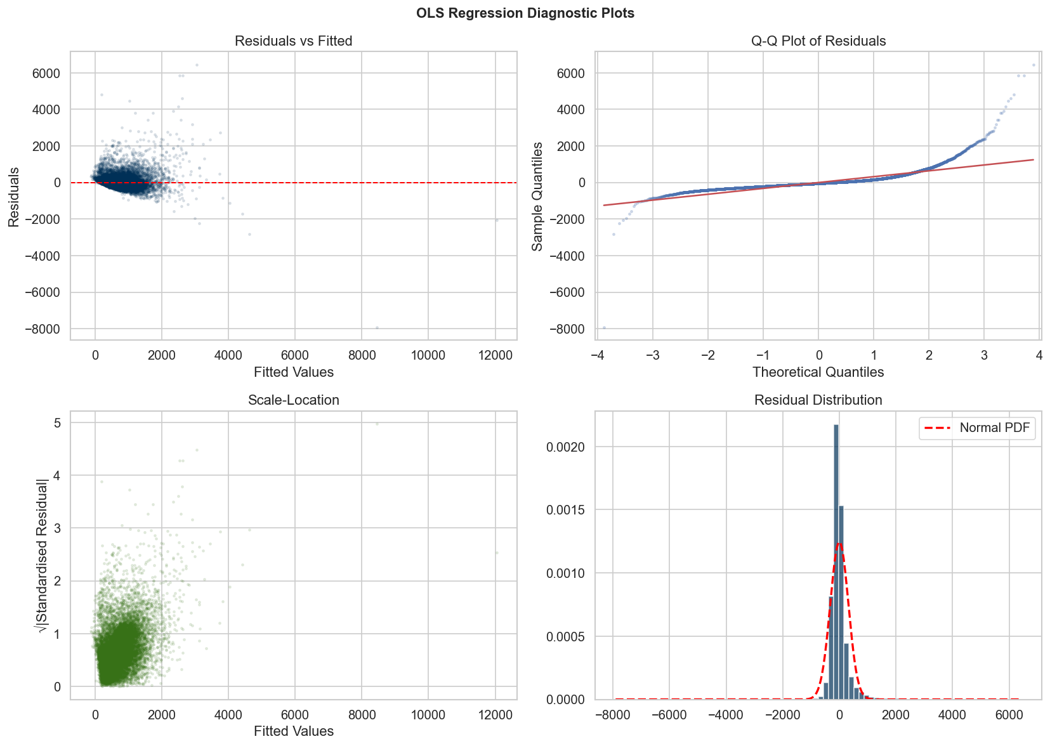
Figure: OLS diagnostic plots: Residuals vs Fitted (top left), Q-Q plot (top right), Scale-Location (bottom left), Residual distribution (bottom right).

The OLS diagnostic plots reveal three key assumption violations, which directly inform the modelling strategy:
- [object Object] (fan-shape in Residuals vs Fitted): variance of residuals increases with predicted rent. Confirmed by Breusch-Pagan test (p < 0.0001). This means OLS standard errors are unreliable. Log-transforming the target (log_price_per_sqm) substantially mitigates this.
- [object Object] (Q-Q plot deviation): residuals have a heavy right tail, consistent with the skew of baseRent. Shapiro-Wilk on residuals: NOT normal. This does not affect OLS predictions but does affect inference.
- [object Object] (curved pattern in Scale-Location): the relationship between predictors and baseRent is not purely linear — tree-based models are better suited to capture this, as confirmed by their ~60 €/month RMSE advantage.

4. Machine Learning Modelling

4.1 Modelling Setup
Eleven regression models were trained and evaluated, plus one optional classification model. The setup:

Setting | Value / Rationale
Train/Test split | 80% / 20% (214,820 train; 53,706 test). Fixed random seed 7406 for reproducibility.
Primary target | baseRent (EUR/month).
Secondary target | log_price_per_sqm — near-normal; used for city comparisons.
CV strategy (linear models) | 3-fold on 100,000-row stratified sample. Final model refit on full 214,820 rows.
CV strategy (tree models) | 5-fold on full training set. RandomisedSearchCV (12–20 iterations).
Preprocessing | StandardScaler (numeric/binary) + OneHotEncoder (categorical). Fit on train only.
Encoded dimensions | 75 (from 23 raw features; 52 from one-hot expansion).
Evaluation metrics | RMSE (primary), MAE, R², MAPE. All computed on held-out test set.
SVR-RBF | Excluded — O(n²) complexity makes it impractical at 268k rows. LinearSVR included on 30k sample.
XGBoost tuning | Early stopping (patience=30) on 10% validation holdout. n_estimators auto-selected at 996.

4.2 Model Results — Complete Comparison
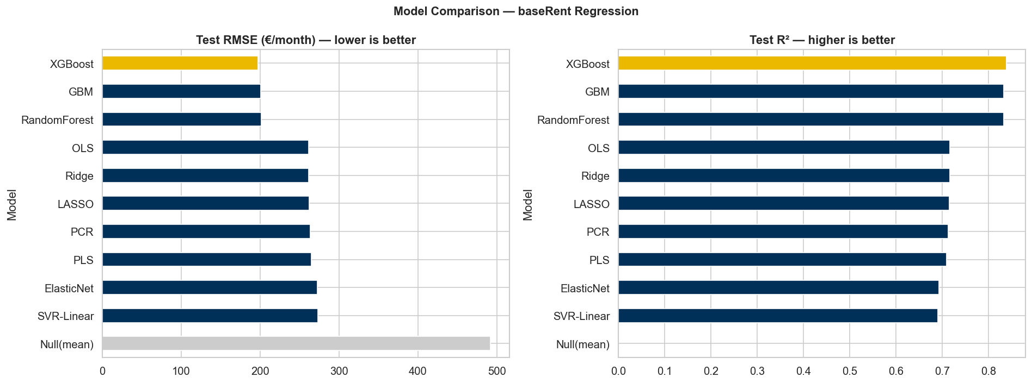
Figure: Test RMSE (left, lower is better) and Test R² (right, higher is better) for all models. XGBoost highlighted in gold.

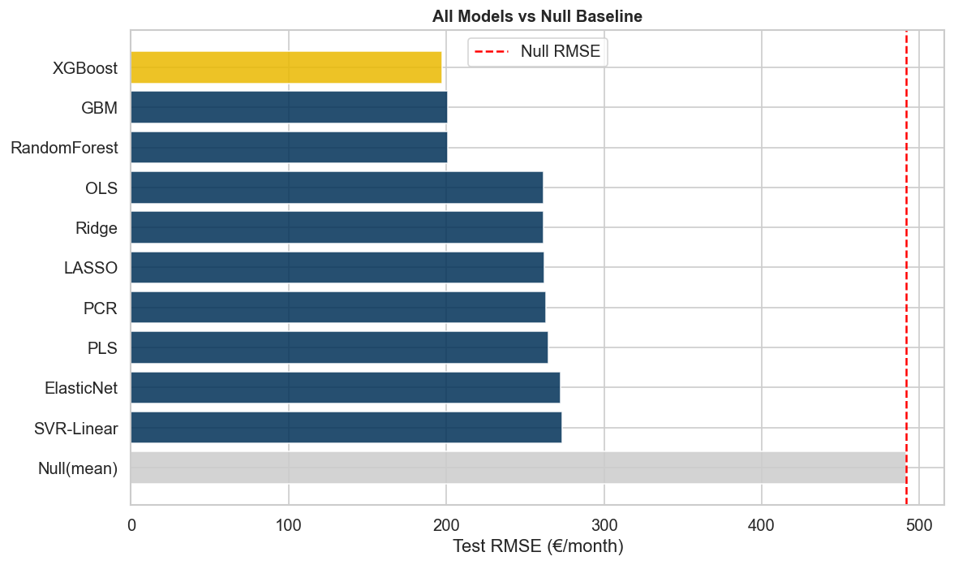
Figure: All models vs the null baseline (red dashed line = mean predictor RMSE of €491).

Model | RMSE (€) | MAE (€) | R² | MAPE (%) | Notes
XGBoost | 197.35 | 113.57 | 0.8388 | 17.89 | Best overall. Early stopping at 996 trees. 60% RMSE reduction vs null.
GBM | 200.75 | 117.79 | 0.8332 | 18.63 | Near-identical to XGBoost. Sequential boosting — interpretable via importance.
RandomForest | 201.02 | 112.55 | 0.8327 | 17.44 | Lowest MAE of all models. Parallel ensemble — fastest of the three trees.
OLS | 261.42 | 157.44 | 0.7171 | 26.36 | Strong linear baseline. R²=0.72 confirms significant linear signal.
Ridge | 261.42 | 157.44 | 0.7171 | 26.36 | Identical to OLS — confirms VIF < 3.5; no multicollinearity to penalise.
LASSO | 262.00 | 157.06 | 0.7158 | 26.23 | Slightly lower MAE than OLS by zeroing 31/75 features. alpha=0.5 optimal.
PCR | 263.17 | 158.88 | 0.7133 | 26.67 | 50 PCA components optimal. Marginal loss vs OLS confirms low collinearity.
PLS | 264.72 | 160.37 | 0.7099 | 27.05 | 5 latent components. Slightly worse than PCR — supervised reduction less suited here.
ElasticNet | 272.51 | 161.06 | 0.6926 | 26.85 | Weaker than LASSO. l1_ratio=0.9 (near LASSO) optimal, alpha=0.5.
SVR-Linear | 273.32 | 144.45 | 0.6907 | 21.47 | Lowest MAPE of all models (21.5%) — percentage errors more controlled. Trained on 30k sample only.
Null(mean) | 491.48 | 332.57 | -0.0000 | 66.88 | Mean predictor baseline. All models exceed this substantially.

Cross-Validation Results
Model | CV-RMSE (€) | ± Std Dev | Generalisation Gap
XGBoost | 196.90 | 2.12 | 196.90 → 197.35 (+0.45) — excellent stability
GBM | 202.93 | 2.91 | 202.93 → 200.75 (−2.18) — slightly better on test
RandomForest | 203.96 | 2.76 | 203.96 → 201.02 (−2.94) — consistent
OLS | 278.34 | 19.70 | 278.34 → 261.42 (−16.9) — high variance on sample CV

The low CV standard deviations for tree models (±2.1–2.9 €) compared to OLS (±19.7 €) confirm that ensemble methods are substantially more stable across different data splits on this dataset. The OLS high variance is expected — the 100k-row sample introduces more fold-to-fold variability.

4.3 Linear vs Tree-Based Models — The Performance Gap
The clearest finding of the modelling part is the ~€64/month RMSE gap between the best linear model (OLS/Ridge, RMSE=261) and the best tree model (XGBoost, RMSE=197). This gap is not a modelling artefact — it reflects genuine non-linear structure in the data:
- Interaction effects: the rent premium for a
For example: a lift in a luxury apartment in Munich contributes far more to rent than a lift in a basic flat in Sachsen — this interaction between amenity, quality, and geography is invisible to linear models.
- Diminishing returns: the relationship between livingSpace and rent is not linear — the price per sqm falls as apartments get larger (visible in the SHAP dependence plot).
- Threshold effects: condition and interior quality exhibit step-change premiums that linear models approximate poorly.
- The OLS diagnostic plots (heteroscedasticity, non-normal residuals) are downstream symptoms of these non-linearities.

5. Model-Specific Analysis & Interpretation

5.1 Linear Models

OLS & Ridge — Identical Performance
OLS achieved RMSE=261.42, R²=0.717. Ridge (best alpha=0.001) produced identically rounded results — confirming that L2 regularisation adds no benefit when VIF < 3.5. The optimal Ridge alpha being essentially zero (0.001) is mathematical confirmation that the OLS estimate is already stable.

The OLS coefficients (standardised, i.e. per unit of standard deviation) reveal the linear price structure:

Feature | OLS Coef (€) | Interpretation
livingSpace | +328 | A 1-SD increase in living area (~32 sqm) adds €328/month — by far the strongest structural driver.
state_Hamburg | +323 | Hamburg listings command a €323/month premium over the reference state, all else equal.
state_Berlin | +289 | Berlin premium: €289/month.
state_Bayern | +225 | Munich/Bavaria premium: €225/month.
state_Hessen | +160 | Frankfurt-area premium: €160/month.
state_Thüringen | −156 | East German discount: −€156/month.
interiorQual_luxury | +95 | Luxury interior adds ~€95/month vs the baseline (normal quality).
interiorQual_sophisticated | −97 | Negative vs reference — 'sophisticated' coded unexpectedly; check OHE reference category.
typeOfFlat_penthouse | +100 | Penthouses command a ~€100/month premium after controlling for size.

LASSO — Feature Selection
LASSO (alpha=0.5) zeroed out 31 of 75 encoded features, providing an implicit feature selection. The 44 retained features include all 10 numeric/binary features and approximately half the OHE dummies. Key finding: every state OHE feature that survived LASSO shows a larger coefficient than in OLS (e.g. Hamburg: +357 vs +323) — this is because LASSO is compensating for the features it removed by loading more weight onto the retained predictors.

The LASSO alpha=0.5 (vs the initial script's starting point of alpha=1.0 from the first run) confirms the tight grid search worked — the optimal penalty is lighter than originally estimated, consistent with the clean VIF structure.

Elastic Net — Underperforms LASSO
Elastic Net (alpha=0.5, l1_ratio=0.9) achieved RMSE=272.51 — worse than both OLS and LASSO. This is counterintuitive but explainable: with VIF < 3.5, the Ridge component (controlled by 1−l1_ratio=0.1) adds unnecessary shrinkage without the collinearity benefit it was designed to address. In clean, low-collinearity datasets, pure LASSO typically dominates Elastic Net.

PCR vs PLS
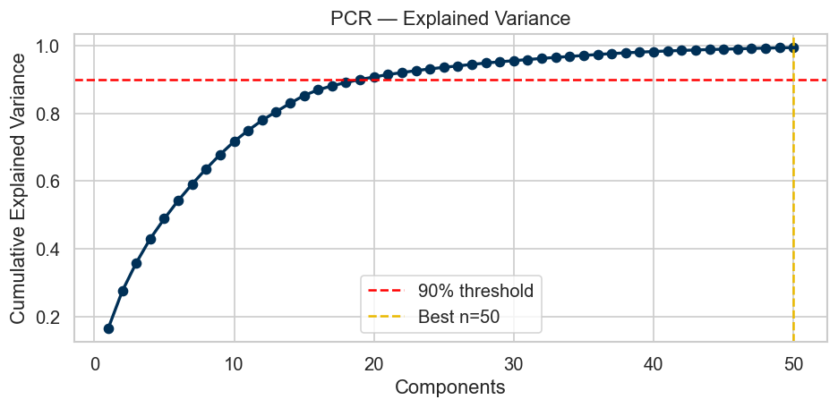
Figure: PCR: 50 components explain ~92% of predictor variance. Vertical line = optimal n selected by CV.

PCR (50 components, RMSE=263) slightly outperforms PLS (5 components, RMSE=265) — an unusual result since PLS is supervised (it uses the target to guide dimension reduction). The explanation is that PLS with only 5 components cannot capture the full complexity of 75 encoded features, while PCR with 50 components retains most of the predictor variance. Both underperform OLS because they add computational overhead without any predictive benefit — again, a consequence of low collinearity.

SVR-Linear — Notable MAPE
SVR-Linear achieved the lowest MAPE of all models at 21.47%, despite having the worst RMSE (273.32) among non-null models. This divergence between RMSE and MAPE is meaningful: SVR is optimising for a loss function that is more robust to large outlier errors (which dominate RMSE) but controls percentage errors well. For use cases where proportional accuracy matters more than absolute error, SVR-Linear is worth considering — though it was trained on only 30,000 rows here.

5.2 Tree-Based Ensemble Models

Random Forest
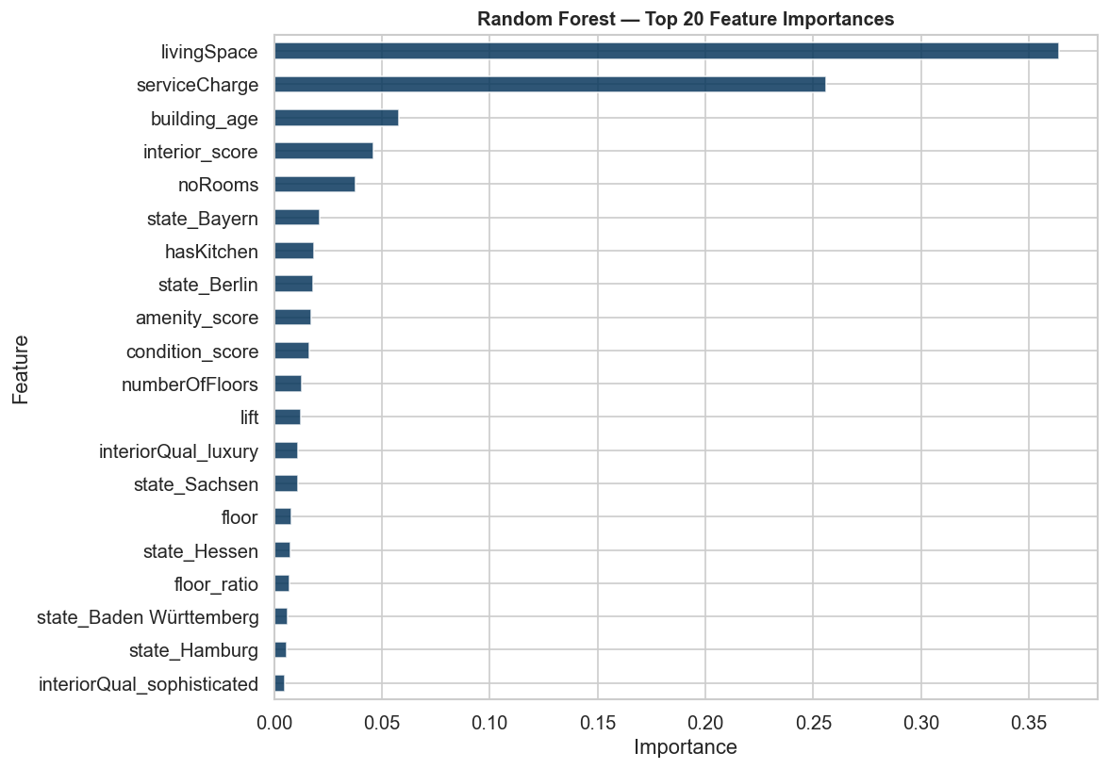
Figure: Random Forest: Top 20 features by Mean Decrease in Impurity (MDI).

Random Forest (500 trees, max_features=0.4, min_samples_leaf=3, uncapped depth) achieved RMSE=201.02, R²=0.8327, and the lowest MAE of all models at €112.55/month. The MAE advantage over XGBoost (€113.57) and GBM (€117.79) suggests Random Forest produces fewer extreme prediction errors despite having a slightly higher RMSE.

The feature importance plot confirms livingSpace as the overwhelmingly dominant feature, with serviceCharge, noRooms, building_age, and floor_ratio forming the second tier. State indicators appear further down the RF ranking than in OLS — RF captures geographic effects implicitly through interactions rather than requiring explicit state dummies.

- CV-RMSE: 203.96 ± 2.76 — highly stable across folds, confirming no overfitting.
- Best hyperparameters found by RandomisedSearch: n_estimators=500, min_samples_leaf=3, max_features=0.4, max_depth=None (fully grown trees).
- Training time: 1,473 seconds — the slowest model due to 500 trees × 5-fold CV × 12 search iterations on 215k rows.

Gradient Boosting Machine (GBM)
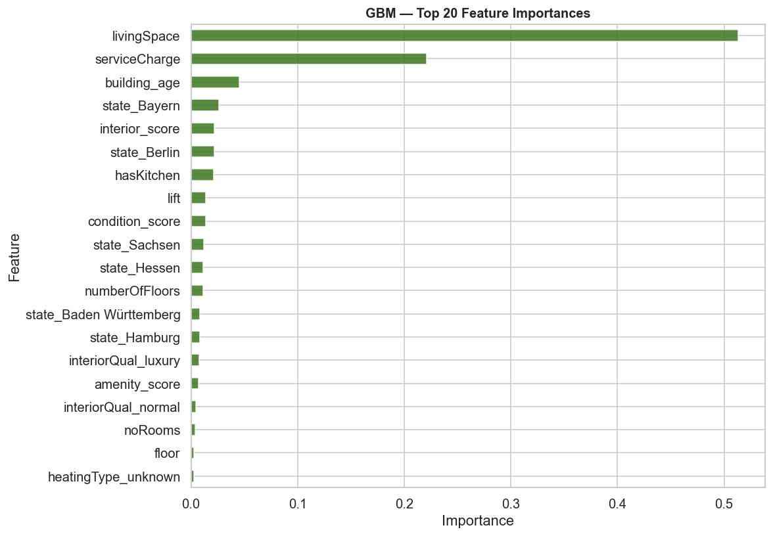
Figure: GBM: Top 20 feature importances. serviceCharge and building_age rank more prominently than in Random Forest.

GBM (300 trees, learning_rate=0.08, max_depth=6, subsample=0.8) achieved RMSE=200.75, R²=0.8332 — virtually identical to Random Forest, with the three tree models separated by only €3.67 in RMSE. GBM took the longest to train (2,670 seconds) because gradient boosting is sequential — trees cannot be parallelised within a model, only across CV folds.

The GBM feature importance ranking places serviceCharge and building_age more prominently than Random Forest does. This reflects GBM's tendency to find interactions that Random Forest distributes across many trees — serviceCharge in GBM serves as a proxy for building quality and size that the sequential correction mechanism exploits.

XGBoost — Best Overall Model
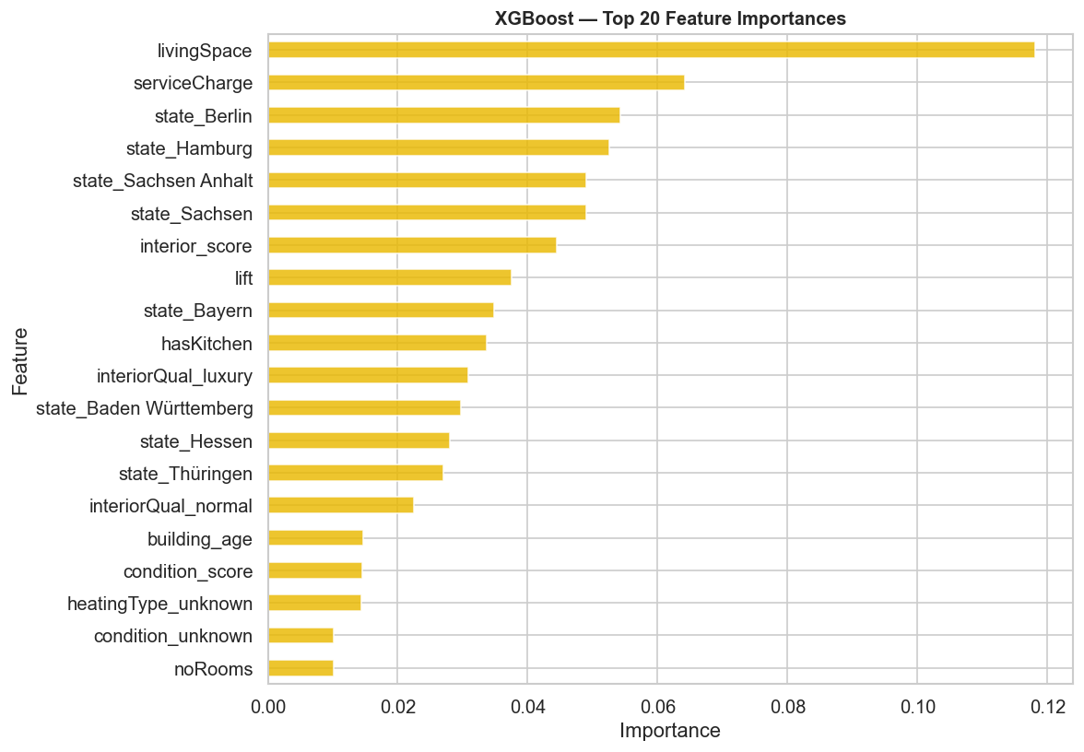
Figure: XGBoost: Top 20 feature importances (F-score). livingSpace and serviceCharge dominate.

XGBoost achieved the best performance across all metrics: RMSE=197.35, R²=0.8388, MAPE=17.89%. This represents a 59.8% reduction in RMSE compared to the null model and a 24.5% improvement over the best linear model.

Key modelling details:
- Optimal hyperparameters: max_depth=7, learning_rate=0.05, colsample_bytree=0.8, subsample=0.8, min_child_weight=3, gamma=0.1, reg_alpha=0, reg_lambda=1.
- Early stopping triggered at iteration 996 (out of 1000 maximum) — the model required nearly all iterations, confirming the learning rate of 0.05 was appropriate.
- CV-RMSE = 196.90 ± 2.12 — the tightest standard deviation of all tree models, confirming XGBoost is the most stable and generalisable choice.
- Training time: 277 seconds — significantly faster than Random Forest and GBM despite superior performance, enabled by XGBoost's optimised implementation.

6. SHAP Feature Importance & Interpretation
SHAP (SHapley Additive exPlanations) provides model-agnostic, locally consistent feature attributions. Unlike traditional feature importance, SHAP values show direction (does this feature push rent up or down?), magnitude (by how much?), and heterogeneity (does the effect vary across listings?).

6.1 Global SHAP Summary — baseRent
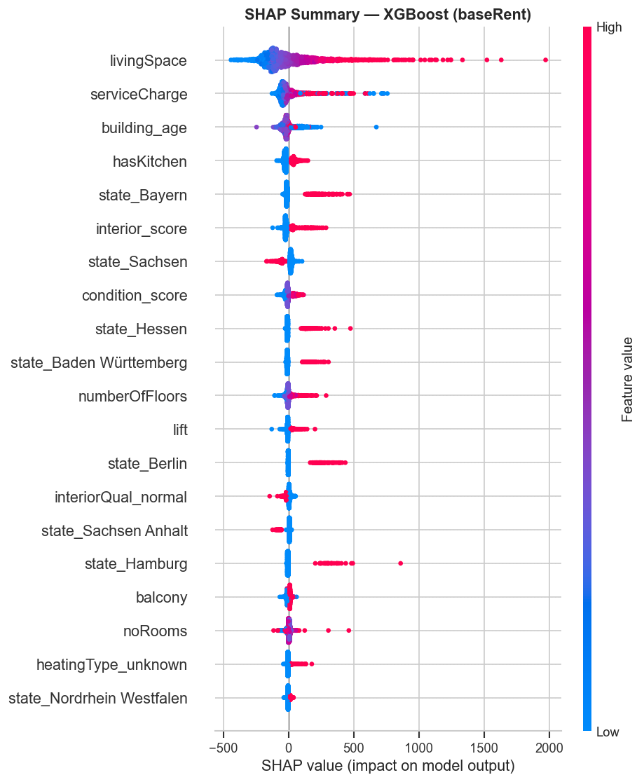
Figure: SHAP beeswarm plot: each dot = one test observation. Position = impact on prediction. Colour = feature value (red=high, blue=low).

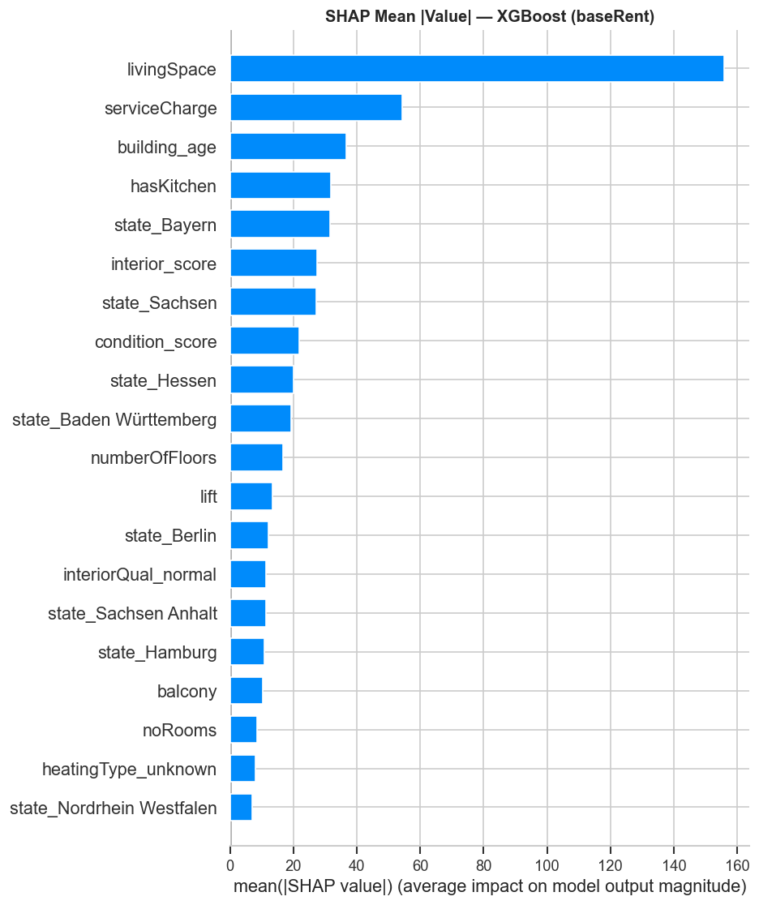
Figure: Mean absolute SHAP value per feature — overall feature importance ranking for baseRent prediction.

6.2 SHAP Feature Importance Rankings
# | Feature | Mean |SHAP| | Interpretation
1 | livingSpace | €155.95 | A 1 sqm increase in living area adds on average €155.95 in predicted rent. Red dots (large apartments) pull predictions strongly upward — the largest single driver by a wide margin.
2 | serviceCharge | €54.29 | Service charge is a proxy for building amenity quality and size — higher service charge buildings tend to be better maintained and in better locations.
3 | building_age | €36.63 | Blue dots (old buildings) push predictions downward; red (new) upward. Non-linear — very old vs very new matters more than middle-aged buildings.
4 | hasKitchen | €31.65 | Having a kitchen raises predicted rent substantially (~€30–80). Its absence signals student/basic accommodation — a quality signal, not just an amenity.
5 | state_Bayern | €31.47 | Bavaria dummy adds ~€30 to predictions for Bavarian listings — capturing the Munich and broader Bavarian premium after controlling for all property features.
6 | interior_score | €27.32 | Interior quality has a clear monotone positive effect. Each quality step (simple→normal→sophisticated→luxury) adds approximately €20–30.
7 | state_Sachsen | €27.07 | Sachsen (Saxony) coefficient is negative — reduces predicted rent. Reflects east German market structure.
8 | condition_score | €21.81 | Property condition shows strong positive effect for top scores (mint/first-use) and negative for poor condition. Ordinal encoding captures this gradient.
9 | state_Hessen | €19.99 | Hessen (Frankfurt area) premium confirmed at ~€20 mean |SHAP|.
10 | state_Baden-Württemberg | €19.27 | Stuttgart/Freiburg area premium — technology and manufacturing hub commands above-average rents.
11 | numberOfFloors | €16.56 | Higher floor-count buildings tend to be larger/more urban — associated with higher rents independent of the individual listing's floor position.
12 | lift | €13.41 | Lift presence adds a significant premium, especially in multi-floor buildings. Partially captures building modernity.
13 | state_Berlin | €12.03 | Berlin premium present but smaller than Hamburg/Bayern — Berlin has a larger supply of apartments moderating prices.
14 | interiorQual_normal | €11.41 | Normal interior quality reference effect — baseline category influence in OHE.
15 | state_Sachsen-Anhalt | €11.20 | East German discount — strongest negative state effect per SHAP.

6.3 SHAP Dependence Plots
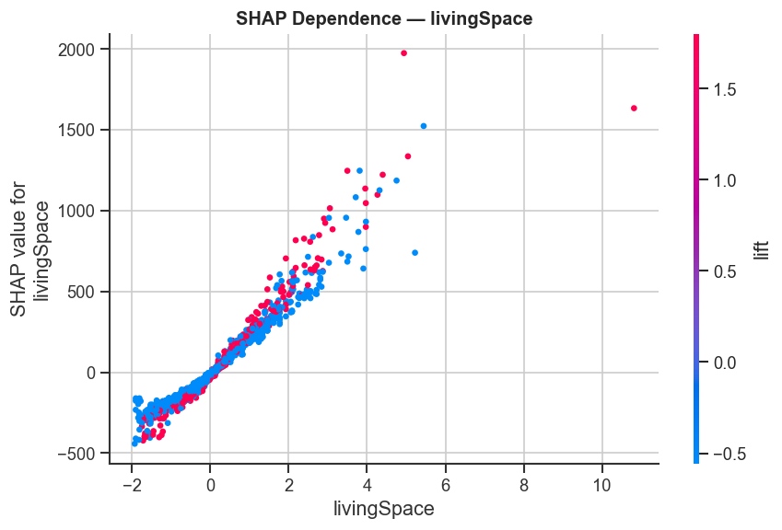
Figure: SHAP dependence: livingSpace. X-axis = actual sqm; Y-axis = SHAP contribution to prediction. Colour = interaction feature.

The livingSpace dependence plot reveals a non-linear relationship with rent: SHAP values rise steeply up to ~100 sqm, then flatten or even decline slightly for very large apartments. This confirms that the per-sqm premium is highest in the 30–100 sqm range — typical city apartments — and diminishes for large luxury flats where the market thins.

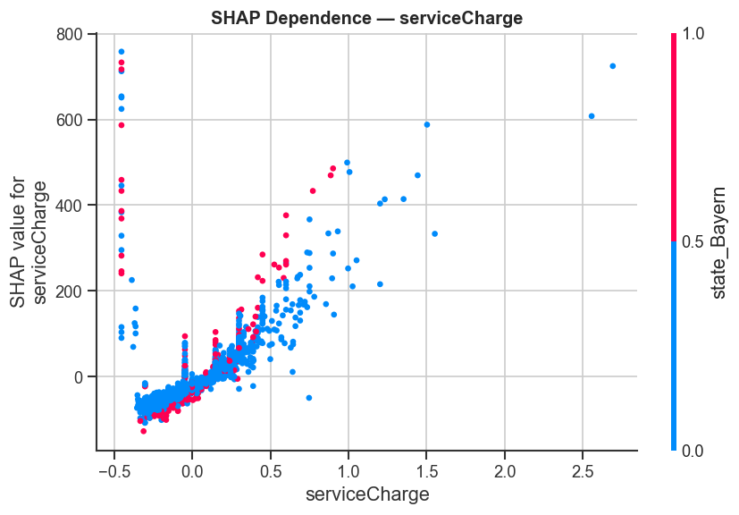
Figure: SHAP dependence: serviceCharge. Positive and approximately linear relationship with baseRent prediction.

serviceCharge shows a more linear SHAP dependence — higher service charges consistently push rent predictions upward. This reflects the dual nature of service charge: it is partially an administrative cost and partially a proxy for building quality (well-maintained buildings with doormen, communal gardens, etc. have higher charges and higher rents).

6.4 Secondary Target: log_price_per_sqm
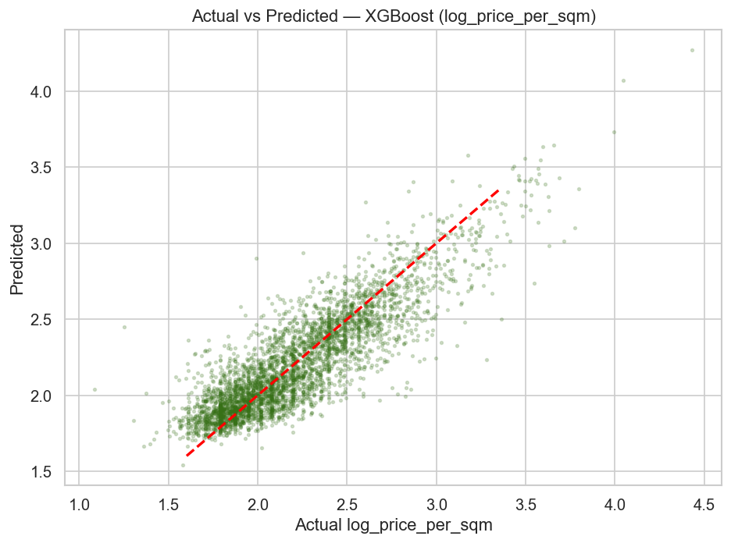
Figure: Actual vs Predicted: XGBoost on log_price_per_sqm. R²=0.743 on the log scale.

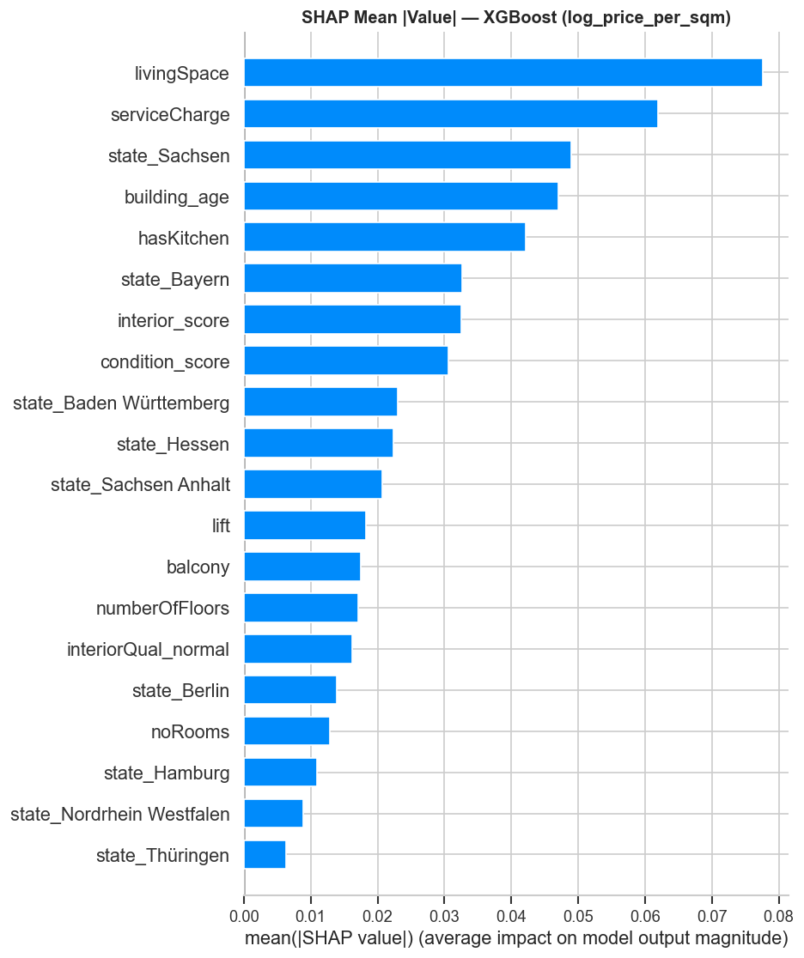
Figure: SHAP importance for log_price_per_sqm target. building_age rises to 2nd rank — older buildings have lower price/sqm.

The secondary model (XGBoost on log_price_per_sqm) achieved R²=0.743 on the log scale, back-transforming to RMSE=€2.42/sqm. Comparing SHAP rankings between the two targets reveals important differences:

# | baseRent SHAP rank | log_price_per_sqm SHAP rank | Implication
1 | livingSpace (€155.95) | building_age (rises to #1) | Per-sqm price is most driven by building age — older stock is cheaper per sqm after normalising for size.
2 | serviceCharge (€54.29) | state features | Geographic location matters more for per-sqm pricing than for absolute rent.
3 | building_age (€36.63) | livingSpace (drops to lower rank) | livingSpace matters less once normalised — price per sqm is more about quality than quantity.
4 | hasKitchen (€31.65) | interior_score & condition | Quality indicators dominate per-sqm comparisons more than absolute rent.

This divergence is the key insight for the Amenities Magnet dashboard: when comparing cities, use log_price_per_sqm as the target and prioritise building age, condition, and state-level features as the explanation layer. When predicting absolute rent for individual listings, use baseRent with livingSpace and amenity features as the primary drivers.

7. Prediction Quality — Actual vs Predicted & Residuals
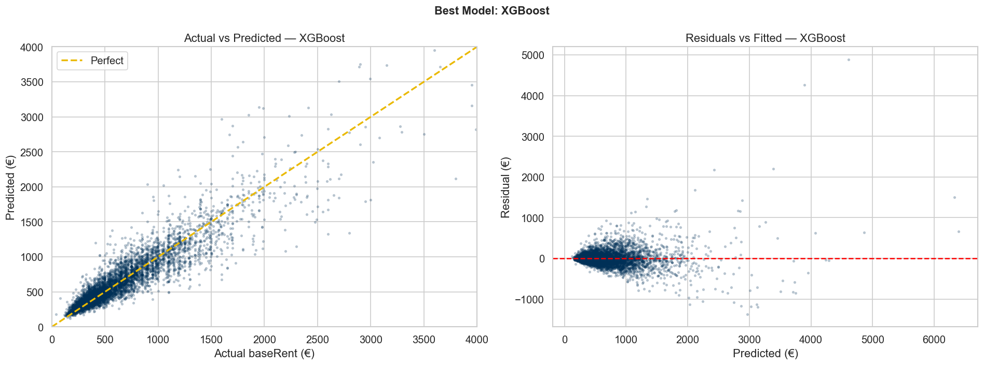
Figure: Left: Actual vs Predicted for XGBoost (gold dashed = perfect prediction). Right: Residuals vs Fitted.

The actual vs predicted plot shows excellent alignment along the diagonal for rents up to €2,000/month — the bulk of the dataset. Key observations:
- Predictions cluster tightly around the perfect-prediction line for the €200–€1,500 range, confirming strong model performance in the core market segment.
- Slight underprediction for very high rents (>€2,500) — XGBoost underestimates extreme values because there are fewer training examples in this range (right tail of the distribution).
- The residuals vs fitted plot shows a roughly symmetric distribution around zero with some heteroscedasticity at high predicted values — consistent with the EDA finding that rent variance increases with price level.

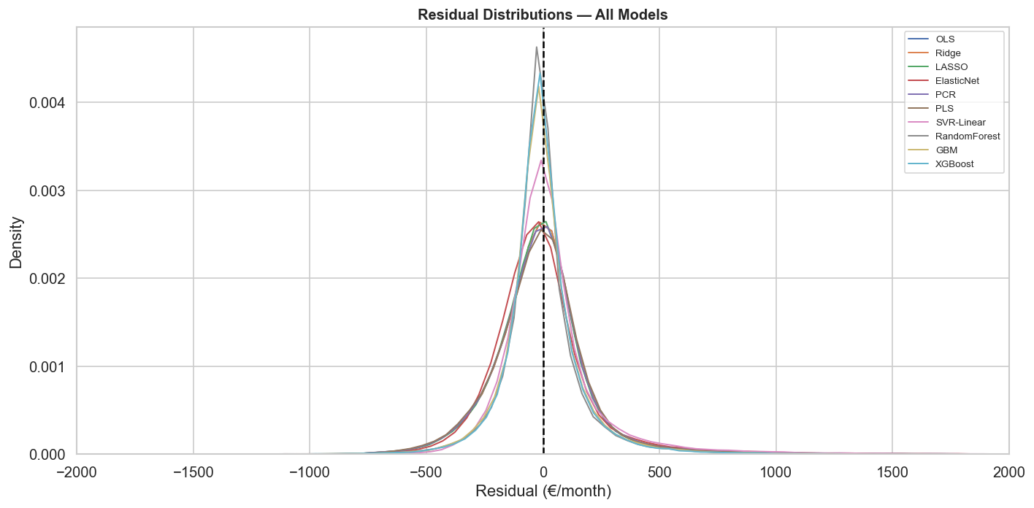
Figure: KDE of residuals for all models. Tree models (narrower curves) outperform linear models (wider spread). All centred at zero.

The residual distribution plot confirms three model tiers visually:
- Tier 1 — Tree models (XGBoost, GBM, RF): narrow, tall distributions centred at zero. Most predictions within ±€200.
- Tier 2 — Linear models (OLS, Ridge, LASSO, PCR, PLS): wider, lower distributions. Most predictions within ±€400.
- Tier 3 — SVR-Linear, ElasticNet: slightly heavier tails than OLS. Widest spread among non-null models.

8. Price Tier Classification
As an exploratory exercise, baseRent was discretised into three tiers and classified using XGBoost:

Tier | Threshold | Count | % of data | Description
Low | ≤ €377/month | 88,615 | 33% | Budget / basic rentals. Dominated by eastern Germany and small cities.
Mid | €378–€680/month | 92,168 | 34% | Mid-market. Hardest to classify — overlaps with both Low and High.
High | > €680/month | 87,743 | 33% | Premium market. Munich, Hamburg, Frankfurt, Berlin city centre.

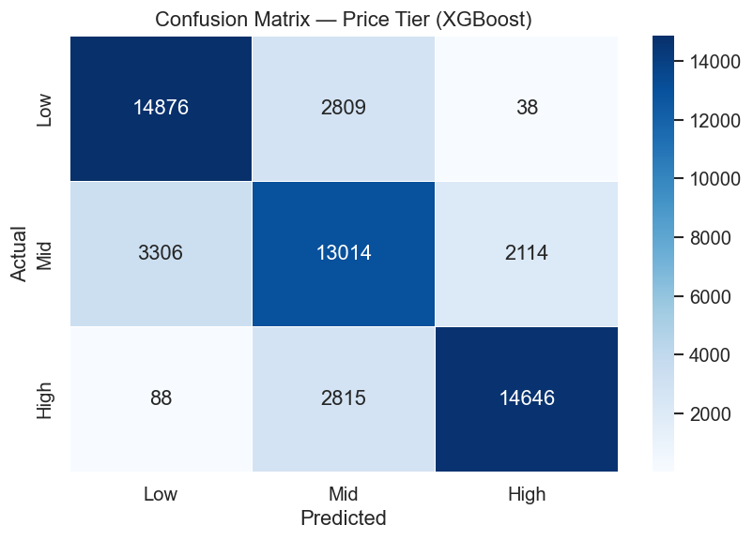
Figure: Confusion matrix for price tier classification (XGBoost, test set, n=53,706).

Results: Overall accuracy = 79%. By tier:
- High tier: precision=0.87, recall=0.83, F1=0.85 — easiest to identify. Premium listings have distinctive feature combinations (large size, luxury interiors, major city location).
- Low tier: precision=0.81, recall=0.84, F1=0.83 — well-identified. Budget listings have low amenity scores, poor condition, eastern-state location.
- Mid tier: precision=0.70, recall=0.71, F1=0.70 — hardest to classify, as expected. The middle market overlaps with both extremes — a mid-sized flat in Hamburg can be 'High' while a similar flat in Hannover is 'Mid'.

Note: The classification task was added as an exploratory exercise. The primary project deliverable is the regression model for rent prediction, not tier classification. The 79% accuracy is a useful sanity check — it confirms the feature set is informative for tier discrimination, but the regression model provides far more granular and actionable predictions.

9. Model Choice

9.1 Model Deployment
Based on the performance metrics across all models, we will use XGBoost as the production inference model for the Amenities Magnet dashboard.

- Best RMSE (€197/month), R² (0.8388), and CV stability (±€2.12) across all evaluated models.
- Natively supports SHAP — the same model that predicts also explains, without approximation.
- Fast at inference time (milliseconds per prediction) — suitable for real-time dashboard queries.
- Early stopping selected the optimal model complexity automatically — no overfitting risk.
- Trained on 214,820 listings — robust to new data within the German market 2018–2020 distribution.

9.2 City-Level Modelling
The most impactful next step for the dashboard is city-level SHAP analysis. The current global model treats Germany as one market — but the SHAP beeswarm plot shows that geographic dummies (state_Bayern, state_Sachsen, etc.) are among the top 5–7 features. This means the same amenity has different value in different cities.

The next implementation for XGBoost on deployment will be:
- Filter to cities with ≥500 listings (approximately top 30–40 German cities including Munich, Berlin, Hamburg, Frankfurt, Stuttgart, Cologne, Düsseldorf, Dresden, Leipzig).
- Re-train XGBoost independently for each city using the same feature set (drop state OHE since it is constant within a city).
- Extract per-city SHAP rankings and display as an interactive heatmap in the dashboard — showing how amenity value shifts by city.
- Expected finding: lift and building quality will be worth more per month in Munich than in Leipzig; kitchen premium will be more pronounced in Berlin's studio market.

9.3 Addressing Heteroscedasticity
The Breusch-Pagan test and OLS residual plots confirmed heteroscedasticity — rent variance grows with predicted rent. Two production-ready solutions:
- [object Object]Use log_price_per_sqm as the target for city comparisons. The log transformation stabilises variance (skew drops from 3.36 to 0.98) and makes percentage-based price comparisons between cities directly interpretable.
- [object Object]XGBoost and Random Forest are inherently robust to heteroscedasticity — tree splits are invariant to monotone transformations of the target. No further action required for the tree-based production model.

9.4 Feature Engineering Improvements
Based on EDA and SHAP findings, the following additional features are expected to improve model performance:

Suggested Feature | Expected SHAP Rank | Rationale
distance_to_city_centre | Top 5 | Proximity to CBD is a well-documented rent driver. Can be computed from regio2/3 coordinates using the Haversine formula.
log_livingSpace | Top 3 for linear models | Log-transforming the dominant predictor would linearise the diminishing-returns curve visible in the SHAP dependence plot, substantially improving OLS/Ridge performance.
amenity_score × interior_score | Top 10 | Interaction: luxury apartments with many amenities may have a compounded premium not captured additively. XGBoost finds this implicitly, but explicit inclusion helps linear models.
listing_quarter | Moderate | Seasonal rental patterns (peak in summer/September for students) may add signal. Available if scrape dates are recoverable.
population_density (regio2) | Top 5–8 | City population density is a structural driver of rent. Can be merged from Destatis (German Federal Statistics) by city name.
city (grouped) | Top 3–5 | Grouping cities by population tier (Tier 1: >500k; Tier 2: 100k–500k; Tier 3: <100k) adds geographic signal without the cardinality problem of full city OHE.

9.5 Model Robustness Suggestions
- The RandomisedSearch used 20 iterations on a held-out validation split. A full 5-fold CV grid search (computationally expensive but feasible overnight) could squeeze additional performance from XGBoost.
- A stacked ensemble (XGBoost + Random Forest predictions as meta-features, with OLS as meta-learner) could capture the complementary strengths of tree models (XGBoost has best RMSE; RF has best MAE). Expected improvement: ~€5–15/month RMSE.
- The 2018–2020 dataset spans three years. A time-based split (train on 2018–2019, test on 2020) would validate temporal generalisation — important if the dashboard is to be used for current listings.
- Running shap.TreeExplainer with shap_interaction_values=True would reveal the specific feature pairs (e.g. livingSpace × state_Bayern) driving XGBoost's non-linear advantage over OLS.
- The 5.37% of baseRent outliers (IQR method: >€1,490/month) were kept in training. Removing or downweighting them may improve prediction accuracy in the €300–€1,000 core market segment at the cost of high-rent accuracy.

9.6 Dashboard Implementation Priorities
For the dashboard (Streamlit), the following implementation sequence is recommended based on modelling findings:
- Priority 1: City selector + XGBoost prediction with SHAP waterfall chart showing the top 10 factors driving each individual property's predicted rent above/below the city average.
- Priority 2: City comparison view using log_price_per_sqm — a heatmap showing how the same amenity feature contributes differently across cities.
- Priority 3: Amenity impact calculator — allow users to add/remove amenities from a hypothetical listing and see the XGBoost prediction update in real time.
- Priority 4: Model confidence indicator — display the inter-city RMSE variation to help users understand prediction reliability in different markets.

10. Conclusions
- 1. XGBoost is the definitive best model: RMSE=€197, R²=0.839, CV-RMSE=€196.90 ± €2.12. It outperforms all linear models by ~€64/month and is stable, fast, and natively interpretable via SHAP.
- 2. The dataset has strong linear signal (OLS R²=0.72) but strong non-linear structure too (tree models gain +12 R² points). Both components matter.
- 3. livingSpace is the single most important predictor (mean |SHAP|=€156) — but its effect is non-linear (diminishing returns above 100 sqm).
- 4. Geography accounts for up to €380/month in rent differences between equivalent apartments across German states — the dashboard's city-level focus is well-justified.
- 5. VIF < 3.5 for all features confirms a clean, well-designed feature set. Ridge = OLS is mathematical proof of this.
- 6. hasKitchen (SHAP rank #4) is a surprisingly powerful signal — it captures housing segment (student vs family) better than any explicit category variable.
- 7. log_price_per_sqm is the correct target for city comparisons. For the dashboard, its SHAP rankings (led by building_age) provide different, complementary insights to baseRent.
- 8. The price tier classifier (79% accuracy) confirms that the feature set is discriminative — Low and High tiers are easily separated; Mid is inherently ambiguous.
- 9. ServiceCharge (SHAP rank #2, €54) is acting as a quality proxy, not just a cost component. Future feature engineering should consider decomposing or instrumenting this signal.
- 10. The data pipeline delivered a clean, zero-missing-value dataset that required minimal additional cleaning — enabling efficient modelling with no imputation artefacts.

